Required practical activity: Cheek cells
Practical Guide – Cheek Cells

Aim: To stain cheek epithelium cells and use a microscope to study them
Notes and guidance
Discuss this practical with your technician colleague in advance.

This practical this practical should be preceded by the Microscopy practical activity where students learn how to use a microscope with pre-made slides. These can be purchased from most school science suppliers. If possible, invest in a variety of to spark the interest of students interested in different aspects of biology.

Your school’s microscopes may differ to those described here. The easiest for school use are those with built-in lights and rechargeable batteries, however many must be plugged in or have a mirror instead of a lamp. Adapt the method accordingly.

Risk Assessment Notes
A risk assessment must be completed for this practical. The risk assessment should be specific to the class involved and written only by the teaching member of staff. For more guidance refer to CLEAPSS. It is good practice for students to wear safety spectacles during all class practicals and demos.

Any broken glass slides must be reported to the teacher and immediately swept up and disposed of in a sharps waste bin.

It should be emphasised that the implement used to extract cheek cells is clean, and that this is the only time students should ever put something in their mouth in a laboratory.

CLEAPSS: Hazcard 32 Dyes, indicators, and stains; SSS0003 Human body fluids and tissues.

Equipment Per Group | Equipment Diagram  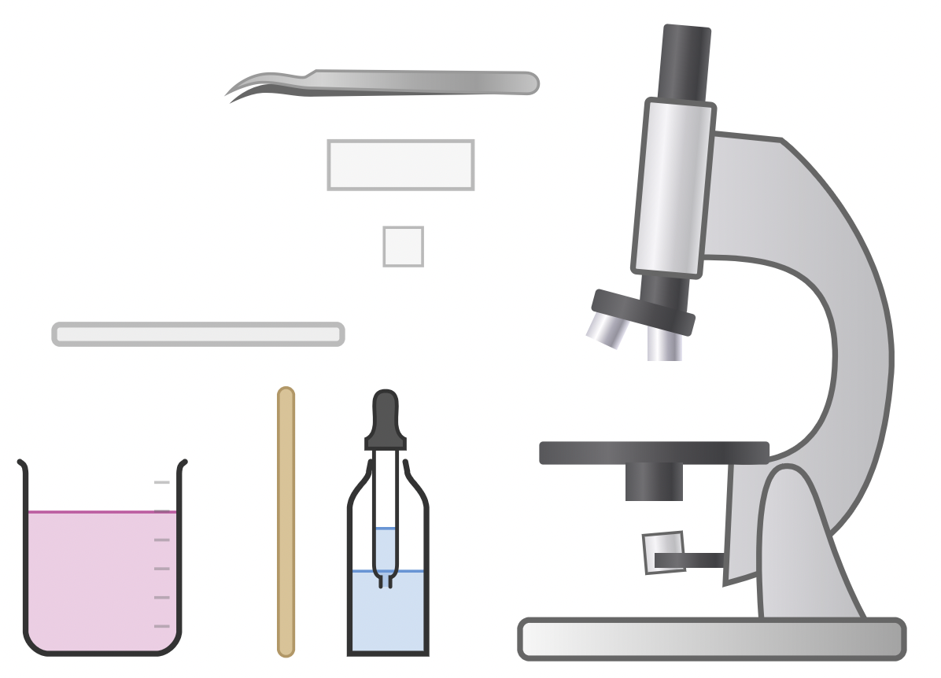
Apparatus:
- Microscope
- Stick to gather cheek cells (rounded, soft-ended, new – e.g. interdental stick or plastic/wooden coffee stirrer)
- White tile
- Blank slide
- Cover slip
- 0.1% methylene blue stain
- Forceps or mounting needle (to place cover slip)
- Beaker of disinfectant (e.g., 1% VirKon)
- Paper towel
- Pencil and paper for drawing

Method |  | Questions To Ask Students During The Practical
- Use a new soft-ended stick to rub the inside lining of both cheeks. This should remove some cheek epithelial cells.  - Place a slide on a white tile and smear your cells onto the centre. Dispose of your used stick in the beaker of disinfectant.  - Place a single drop of 0.1% methylene blue stain over the cell smear on the slide.  - Gently place a cover slip over the cells and use a paper towel to mop up any excess methylene blue stain.  - Place your slide onto the microscope’s stage.  - Rotate the nose piece until the lowest power objective lens is pointing down at the stage. This is usually the x4 objective lens.  - Without looking through the eyepiece yet, turn the course adjustment knob until the lens is almost touching the slide.  - Look through the eyepiece and turn rotate the course adjustment knob slowly to increase the distance between the lens and the slide. Stop when the cells come into focus. A typical eyepiece lens x10 magnification combined with a x4 objective lens would result in a x40 magnification.  - Use the fine adjustment knob to bring the slide into focus.  - Move the slide until you find a good group of cells, then rotate the nose piece to switch to a higher power lens.  - Again use the fine adjustment knob to bring the cells into focus.  - Using a pencil, make a clear and labelled drawing of what you can see. All component parts of the cell should be drawn and labelled.  - Multiply the objective magnification by the eyepiece magnification to find the total magnification. Write this underneath your drawing.  - Dispose of your slide in the beaker of disinfectant. |  | - Why is it important to use a *new* soft-ended stick? (So as we don’t transfer any dirt, chemicals, or bacteria to our mouths.)  - Why do we dispose of the stick and slide in disinfectant solution? (To kill off any bacteria and germs )  - Why must we be gentle when applying the cover slip? (Cover slips are very delicate and can easily break if too much pressure is applied.)  - Why should we mop up any excess stain using a paper towel? (To keep the microscope image as clean as possible and to avoid accidentally staining our hands and work area.)  - Are the higher magnification lenses longer or shorter than the lower magnification lenses? (Higher magnification lenses are [usually] longer than lower magnification lenses.)  - Why are higher magnification lenses usually longer than lower magnification lenses? (They have a longer focal length. [A full explanation of focal lengths and lenses is not necessary for GCSE, and lens designs can vary, but it is useful for students to become more familiar with the microscopes and lenses they are using by paying attention to such physical characeristics.)  - What is the magnificaiton of the eyepice lens? (x10 – on most school microscopes.)  - What is the magnification of the objective lenses? (x4, x10, x40 – on most school microscopes.)  - Why do we start with the slide close to the lens and then lower it until it is in focus? (To do so the other way around would risk pushing the slide up into the lens, which could cause damage.)  - If a microscope had an eyepiece lens of x10 magnification and an objective lens of x100 magnification, what would be the total magnificaiton? (x1000 magnification.)  - Why do we use a pencil for scientific drawings? (It is neater than a pen and mistakes can be corrected.)
Clearing up
It is important that equipment is returned to the prep room in good order. If safe to do so, rinse used equipment and put it in the used equipment tray. If the trays arrived on a trolley, students must return all trays and equipment to that trolley. Anything dirty needs to be placed into a separate container for washing up. Never put dirty equipment back into a tray with clean equipment.

Ensure anything that may have been in contact with human tissue (sticks, slides) is disposed of in a beaker of disinfectant.
Alternative Methods/Computer Simulations
A good alternative to this practical is using iodine to stain onion skin. Supply each group with a small piece of onion, tweezers, a white tile, paper towel, iodine, slide, and cover slip.

- Use the tweezers to remove the skin from the onion piece (smaller than cover slip).
- Place the onion skin on the slide on the white tile.
- Carefully add a small drop of iodine.
- Use the paper towel to soak up any excess iodine.
- Carefully press the cover slip down onto the onion skin (cover slips are very delicate – take care).

It is important to warn students of the hazards of broken glass and iodine. Cover slips must be handled carefully, and any iodine spills on tables or skin must be reported and cleaned up immediately. Iodine stains can be remedied with sodium thiosulfate solution. Stubborn stains will fade over time.
Technician Notes
Discuss this practical with the class teacher ahead of time. Ensure they have considered the risks of this practical and are confident with the techniques and equipment used. If they wish to use iodine to stain onion cells, provide them with the CLEAPSS hazcard (identified in the risk section section above) so they are comfortable with the chemical and how to use and dispose of it safely.

